Formula-3

Formula-3 is an antifungal solution used as treatment for fungal toenails. It has one main antifungal ingredient, Tolnaftate.

USE:
- Clean and dry the affected area
- Apply a thin layer of the product over the affected area twice daily (once in the morning, once at night)

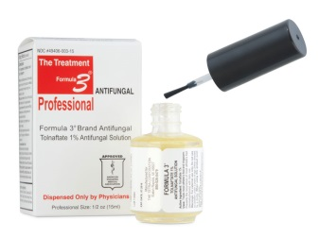

Formula-3

Formula-3 is an antifungal solution used as treatment for fungal toenails. It has one main antifungal ingredient, Tolnaftate.

USE:
- Clean and dry the affected area
- Apply a thin layer of the product over the affected area twice daily (once in the morning, once at night)

