INSTRUCTIONS AFTER NAIL SURGERY 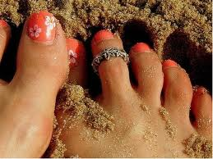
- Keep your bandage on and elevate your foot for the day of surgery whenever possible. Remove the bandage as directed by your doctor.
- If the bandage is difficult to remove, DO NOT PULL! You can soak the foot with the bandage still on in a soaking solution.
- Begin soaking the area 2 times a day for 10 to 15 minutes each time in soaking solution starting the day after surgery and continue until your follow-up appointment; mix warm water with dilute Betadine (2-3 teaspoons per quart of water) to create the soaking solution. NOTE: Warm water, NOT HOT WATER!
- After soaking, dry the area with a clean gauze pad or clean towel.
- Apply antibiotic ointment or drops as ordered by your doctor. Follow with a Band-Aid.
- Some drainage is normal and expected.
- You may take over-the-counter medication such as Advil, Aspirin, Tylenol, or whichever pain reliever you prefer for pain or discomfort as long as you do NOT have an allergy or sensitivity to that medication.
- If Dr. Bailey has prescribed a medicine or a different protocol, please follow that as directed.
- Follow-Up: Please be sure to keep all of your follow-up appointments. The post-op period for this type of procedure is very important and can significantly affect the long term outcome. It is also critical to help prevent infections and/or other possible complications which could lead to a less than optimal result.
- No hot tubs, swimming, or baths; showers only, until otherwise directed by doctor.
- Shoes: You may return to your regular shoe gear whenever it feels comfortable, until then wear the surgical shoe dispensed to you today.
- Continue the above soaking protocol until your follow-up appointment.

